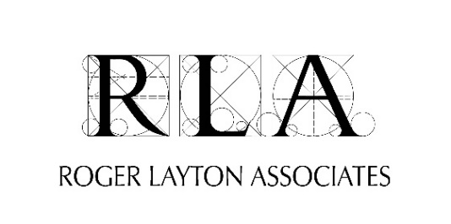
Training Course Application Form
Please complete form and send it mbalisibek@gmail.com or sholeen.sanker@ether.co.za
COURSE: LESSON PLANNING FOR MUSEUM EDUCATION: Feb-Mar 2021
Applicant Name:
Institution:
Position:
Address:
Work Phone: Cell Phone:
Email:
What are your expectations from this workshop?

Course Fee: R2875 (= R2500 + 15% VAT) per delegate.
Following receipt of this application form you will be invoiced for this amount and payment is due prior to the course. Arrangements can be made with institutions to meet SCM policies where these apply, and we will register on the supplier database for the institution as required. We are registered with the CSD.
If this booking is for multiple personnel from your institution, please complete the list of all delegates on the next page.
Signature: Date:

Delegates who will participate in this training course from the institution:
No. | Name | Position | Email
1
2
3
4
5
6
7
8
9
10

